Dynamic Modeling of

Embedded Smartphone Signal Trajectory

This project intends to develop a dynamic model capable of predicting the trajectory of embedded smartphone signals. Specifically, this project intends to model the dynamics of the UCI Human Activity Recognition using Smartphones dataset [1]. This dataset contains signals taken from 30 subjects by smartphones sensors at a constant rate of 50 Hz, along with labels indicating the activity under which the signals were taken. The activity labels include walking, sitting, standing, laying, as well as ascending and descending through stairs. For this project, our proposed model is a hierarchical model consisting of a discrete Hidden Markov process model to model the different activities, a point process model for the data distribution, and a multivariate Gaussian Process (GP) observation model for the observations themselves.

A preliminary model has been developed for this project. In this preliminary method, we first use Principal Component Analysis (PCA), a simple feature extraction method, to reduce the dimensionality of the dataset. Then a Multi-task/Co-regionalized Gaussian Process (GP) Regression model on this human activity dataset [2]. Under this formulation, the spatial correlation and the cross correlation between the multivariate signals are separated, reducing the number of parameters needed to be estimated. In our formulation, we model the signals under different contexts/activities with different GP models to capture dynamics that may differ under different contexts. In the future, we plan to develop a switching Gaussian Process model to combine these models by detecting the change point between different contexts. We train this model by aggregating the signals taken by different subjects under the same context/activity, thereby creating a population model. We use a maximum likelihood approach to optimize the parameters of this model.

Our preliminary results using this model is shown below. In the figures below, we perform prediction indicated by the solid line knowing only the observed points indicated by the diamond shaped points. Nevertheless, we are able to capture the general trajectory of the true observation indicated by the circles. Moreover, notice here that we can see a difference in the behavior of the smartphone signal between the walking context and the sitting context, with the walking context signal fluctuating more rapidly.

Our future work on this project will be to implement a Hidden Markov Model (HMM) layer to model the transitions of our proposed switching Gaussian Process model [3]. We will also relax our population model assumptions, allowing us to model trajectories of different subjects in a personalized fashion [4].

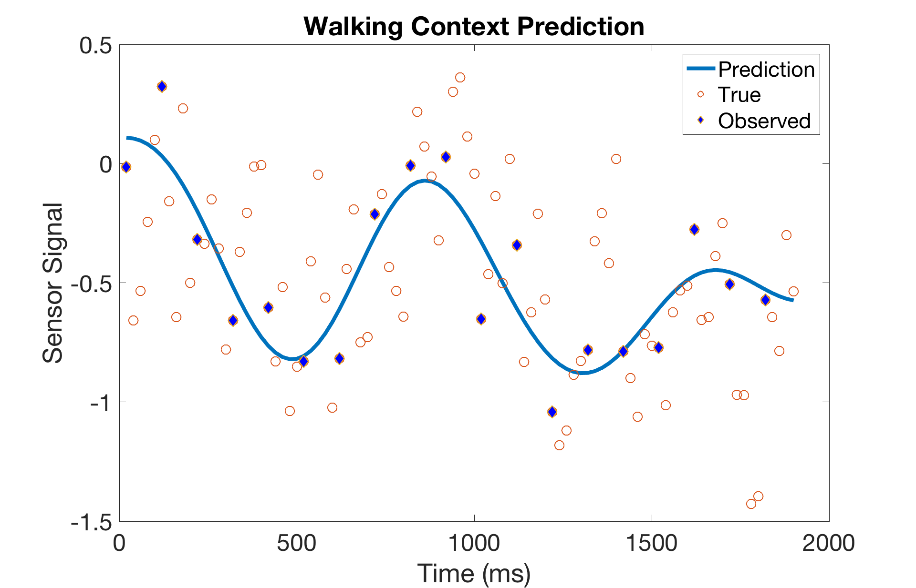

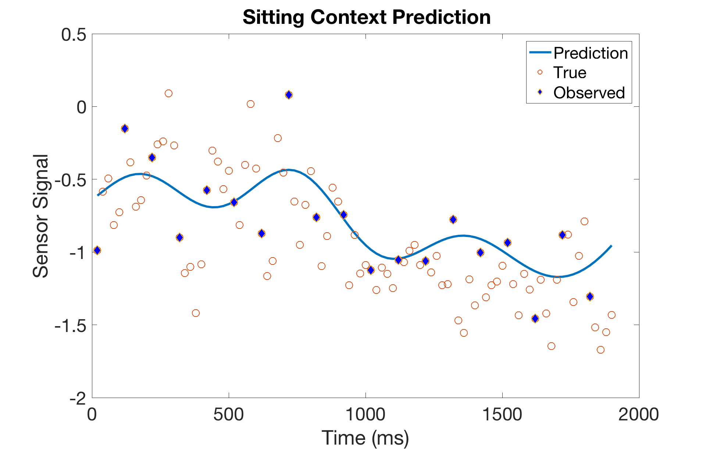

Figure 1: Sensor signal trajectory prediction under 2 different contexts/activities.

References

[1] Davide Anguita, Alessandro Ghio, Luca Oneto, Xavier Parra and Jorge L. Reyes-Ortiz. A Public Domain Dataset for Human Activity Recognition Using Smartphones. 21th European Symposium on Artificial Neural Networks, Computational Intelligence and Machine Learning, ESANN 2013. Bruges, Belgium 24-26 April 2013.

[2] Bonilla, Edwin V., Kian M. Chai, and Christopher Williams. "Multi-task Gaussian process prediction." Advances in neural information processing systems. 2008.

[3] Rabiner, Lawrence, and B. Juang. "An introduction to hidden Markov models." ieee assp magazine 3.1 (1986): 4-16.

[4] Xu, Yanbo, Yanxun Xu, and Suchi Saria. "A Bayesian nonparametric approach for estimating individualized treatment-response curves." Machine Learning for Healthcare Conference. 2016.